**Eric Nay**

**The Bay Area Figurative Movement Word Count: 907**

The Bay Area Figurative Movement, also commonly referred to as the Bay Area Figurative School, was an art movement in the 1950s and 1960s. It was made up of a group of artists working in the San Francisco Bay Area who, in a move away from the New York School mode of abstraction, abandoned painting in the established style of Abstract Expressionism. These West Coast artists focused predominantly on the human body as their subject matter and eschewed Abstract Expressionism’s rejection of representation. The concentration on figurative work ultimately lent the group its name, although its subject matter included landscapes, cityscapes and still lifes as well. The Bay Area artists shared mutual interests and evolved a shared stylistic vocabulary. They received significant critical recognition, and helped redefine figurative art following Abstract Expressionism through a uniquely regional interpretation of modernist painting. The evolution of the Bay Area Figurative Movement was also culturally associated with the rise of beat culture in San Francisco, West Coast jazz, and reactions to World War II. It remains highly contested whether the Bay Area Figurative Movement was a deliberate and rebellious break with Abstract Expressionism or simply a cyclical return to the human figure as subject matter.

However, Bay Area Figurative Movement did more than just return to the human figure. It reintroduced a new sense of subjectivity and humanism to postwar modernist painting, while infusing regional nuances drawn from California’s rich context. The Bay Area Figurists have been described as trying to “domesticate,” rather than reject, Abstract Expressionism in their work, having synthesised figurative subject matter with Abstract Expressionism’s raw methods of paint handling, spontaneous formal composition and emphasis on process. The Bay Area Figurists also added unique regional attributes to their work, including deep, saturated colours and an emphasis on the dramatic play of strong light and shadow, often with ocean backgrounds as a common motif.

Among those associated with the “First Generation” of Bay Area Figurists were Elmer Bischoff (1916-1991), Richard Diebenkorn (1922-1993), Robert Qualters (1934- ), David Park (1911-1960) and Wayne Thiebaud (1920- ). The "Bridge Generation" included the artists Theophilus Brown (1919- 2012), Nathan Oliveira (1928-2010), Roland Petersen (1926- ) and Paul Wonner (1920-2008). Many of the “Second Generation" artists studied under the First Generation artists at institutions that included the San Francisco Art Institute, the California College of Arts and Crafts and the University of California, Berkeley. Among the Second Generation artists were Joan Brown (1938-1990), Bruce McGaw (1935- ), Manuel Neri (1930- ) and Henry Villierme (1928- ).

The Bay Area Figuration Movement could be said to have begun when David Park submitted *Kids on Bikes* (1950), a small figurative painting, to a 1951 competitive exhibition and won. Park had expressed a desire to stop making "paintings" in favor of making "pictures," expressing his own disillusionment with the strict non-representational tenets of Abstract Expressionism. Following suggestions from Park, Richard Diebenkorn, an established and critically recognized Bay Area artist who had attracted considerable national recognition for his abstract work, began to experiment with figurative painting. The paintings Diebenkorn developed following Park merged figurative art with many of Abstract Expressionism’s techniques. Elmer Bischoff, a teacher at the California School for the Arts, began his own transition to figuration three years after Park.

Later work by the Second Generation of the Bay Area Figurative Movement (such as that of Paul Wonner) was mannerist in its approach to the Figurative style. Arbitrary splashes of thick paint are layered on the canvas by Wonner, more as a stylistic device than as a painterly byproduct, showing a clear homage to Abstract Expressionism. Other Second Generation artists, such as Manuel Neri, applied the Bay Area’s expressive approach to figuration to three-dimensional forms of representation in sculpture and other mixed media. Diebenkorn eventually left both the Bay Area and figuration when he moved south to Los Angeles in 1960. In his Santa Monica studio, Diebenkorn produced his most mature work, painting large, simple abstracted landscapes, known as the “Ocean Park” series, which were derived from views from his studio facing outwards towards the Pacific Ocean. Wayne Thiebaud added his own refinements to the Bay Area Figuration Movement’s legacy by borrowing freely from the worlds of graphic design, advertising, and pop art. Thiebaud chose what he referred to as “neglected” subjects, which included pies, majorettes, gumballs, and birthday cakes. These were often rendered using commercial graphic design techniques. By the nineteen seventies, figuration on the West Coast had lost its momentum, but its legacy and much of the influential work produced would form an important chapter in the history of modern art on the West Coast.

**Key Works**

1950 David Park, *Kids on Bikes*

1957 David Park, *Untitled*

*1959* Richard Diebenkorn*, Interior with Book*

*1961* Richard Diebenkorn*, Cityscape No. 1*

*1961* Paul Wonner*, Nude and Indian Rug II*

*1963* Elmer Bischoff*, Breakers*

*1963* Wayne Thiebaud*, Three Machines*

*1963* Wayne Thiebaud*, Girl with Ice Cream Cone*

1964 Paul Wonner*,* Drawing in the Studio

1964 Manuel Neri, *Seated Girl (Bather)*

**References and further reading**

Boas, N. (2012) *David Park: A Painter’s Life*, Berkeley: University of California Press.

Plagens, P. (1974) *Sunshine Muse, Contemporary Art on the West Coast*, New York: Praeger Publishers.

Jones, C.A. (1990) *Bay Area Figurative Art 1950-1965*, Berkeley: University of California Press.

Livingston, J. (1997) *The Art of Richard Diebenkorn*, Berkeley: University of California Press.

Williams, T. (2013) *The Bay Area School, California Artists form the 1940’s, 1950’s and 1960’s*, Surrey, UK: Lund Humphries.

**Visual Material**

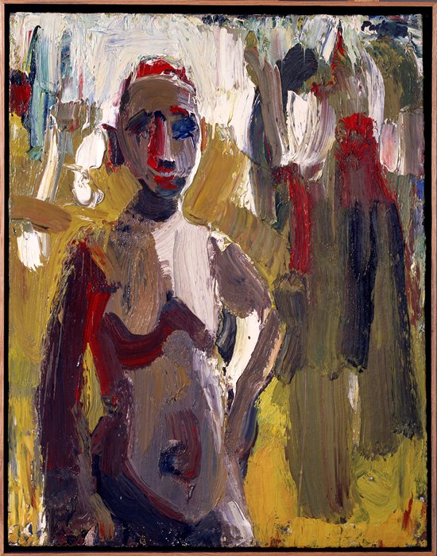

David Park, *Torso*, 1959; oil on canvas, 36 3/8 in. x 27 3/4 in. (92.39 cm x 70.49 cm); Collection SFMOMA, Gift of the Women's Board; © Estate of David Park

Source: <http://www.sfmoma.org/explore/collection/artwork/55#ixzz2qrxpdPTi>   
[San Francisco Museum of Modern Art](http://www.sfmoma.org)

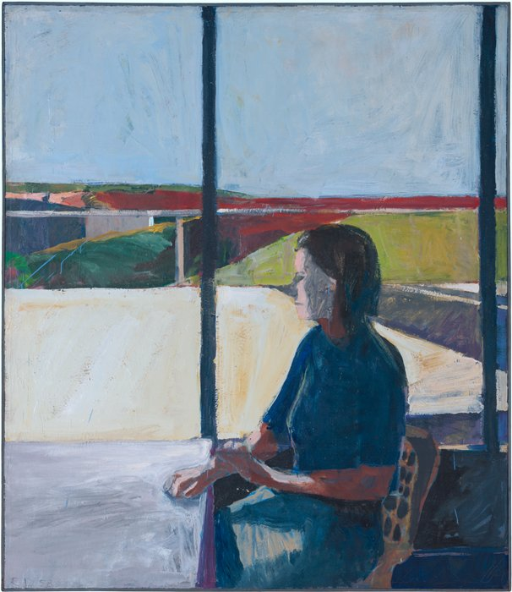

Richard Diebenkorn, *Woman in Profile*, 1958; oil on canvas, 68 1/8 in. x 59 in. (173.04 cm x 149.86 cm); Collection SFMOMA, Bequest of Howard E. Johnson; © Richard Diebenkorn Foundation. Source: <http://www.sfmoma.org/explore/collection/artwork/4421#ixzz2qrzWpTut>   
[San Francisco Museum of Modern Art](http://www.sfmoma.org)

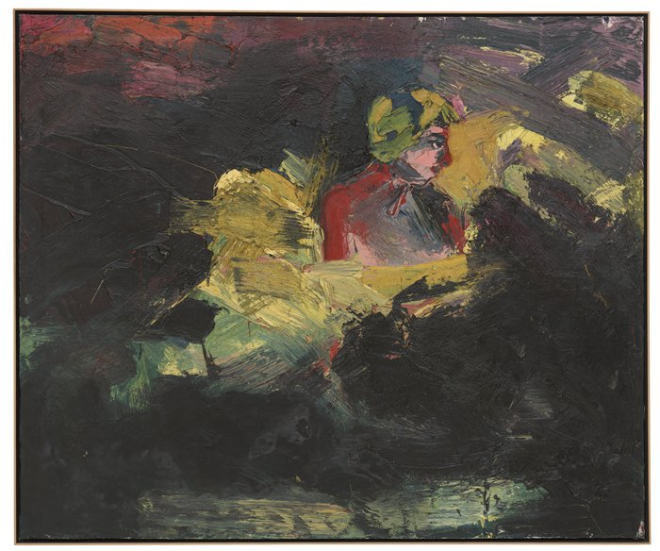

Joan Brown, *Girl Bathing at Night*, 1962; oil on canvas, 60 1/4 in. x 72 in. (153.04 cm x 182.88 cm); Collection SFMOMA, Gift of Modesto Lanzone; © Estate of Joan Brown . Source: <http://www.sfmoma.org/explore/collection/artwork/3749#ixzz2qs0UK2Wi>   
[San Francisco Museum of Modern Art](http://www.sfmoma.org)